Test Fetcher
> Problem Statement:

As we know that the test automation framework uses scenario approach to automate the testing of the website. For this, it uses different scenario information files for each situation.

The scenario information files are excel files, that contain many columns: Some of the columns are:
1.) ACTION_NAME : It contains the action to be performed.
2.) PARAM : It contains the parameter to be passed to the action.
3.) COMM : It contains the comments about the action to be performed.
There can be many columns also.

When a new bug is reported in the system, the process to fix it in the source code is very large. The test automation team has to go through many number of steps. These steps are:
1. Analyzing why this bug occurred.
2. Fixing the bug in the source code.
3. Testing if the bug has been fixed
4. Checking if there exists an existing test for this bug
5. Making sure that the change passes all the existing tests also.

Now, in the fourth step, the user will have to manually go to all the scenarios in the respective folder to check if the test exists already. Also, in the fifth step, the user has to figure out that what other tests can be affected by the current change in the source code.
Currently, these two steps are done manually by the user. The users have to put their valuable time and effort in finding the existing tests, that could be affected by the current change. This increases the time of the business very much.

> Solution:

The solution to this problem is to build a system that will automate the 4th and 5th step.

> Why do we need this solution :

To reduce the time of the business of the user. One of the users here is, the Test Automation team. There can be other users also.

> How we can do it:->

To make a system, that lets the user search the existing tests. The user would be able to search all the SCENARIO_INFORMATION files, based on some input parameters. These parameters would be the columns of the scenario_information files, for example,ACTION_NAME, PARAM or COMM in SCENARIO_A sheet.
This tool would enable the user to make the search very efficient.

> Merits of the system:

1.
Business before:
The user has to search manually for the tests. There are around 2000 tests, so going over each test manually takes a lot of time, which reduces the efficiency of the business.

Business after:
The user won't have to go to each of the test manually. Using this system, the user can search for the test and he can get the results in very less time.

2.
Business before:
The user searches for the tests manually, so there can be a chance of error. For example, every user has to keep record of all the tests that are changed by the other users. If the user doesn't keep track, it can result in an error in his/her business.

Business after:
The system will automatically handle all the changes made by all the users. User need to worry about the changes made by other users.
In this way, the user will get the accurate files that he wants, therefore reducing the chances of any error.

3.
Business before:
If a user has to add a new test, he should check if that test is already present in the test automation repository. If he doesn't check, he may create a duplicate check. Checking it can take a lot of time manually.

Business after:
The user can search in the system if a test already exists in the repository, so that he need not write it again.

This would avoid the unnecessary effort and time of the user, that is used right now.

4.
Business before:
The process of searching manually is not user friendly, that means, there isn't any interface present to perform this. It is not convenient for the user.

Business after:
The system would be very user friendly, as it provides a very simple interface to the user. With that system, the user is only one button away from the results. Along with more speed and less time, it would be very convenient for the user to carry out the search operation.

5.
Business before:
The effort of the user increases when we add new tests to the business. The user has to now spend more time searching for the tests he want.
Business after :
The system will automatically handle the addition of new tests, so that the time to search remains the same

We also aim to handle the deletion or changing of any test in the repository.
> System platform:

The system will be deployed as web service.
The system will, by default keep the index on a remote server. When user performs any operation, the system will exchange data with the server.

> Requirements of the system:

    - A server with some space: The system will require a server with space proportional to the size of the test automation data, but less than it.
    - A local system with network connection : The user would need a local system with internet connection, so that the system can exchange data with the server.
If the user wants, he/she can download the index to his local system.

> Speed of the system:

As the system builds an inverted index of the data, the searching would be very fast.

Also, we are making different indexes for each of the folder, so we can perform the operation in parallel also. This feature of the system can greatly enhance the speed of the user's business.

> How we guaranty the correctness of our system :

After finishing each module of our system, we will write tests for the respective module, to check if it works fine. We will also write tests to ensure that this module doesn't affect the other modules.

After we develop the complete system, we will write tests for the whole system. We will follow the method of regression testing, to ensure that the changes that we include to fix the current bug, doesn't introduce new bugs.

The test automation team will also be consulted to ensure the correctness of our system.

The following diagram explains the work flow of our system.

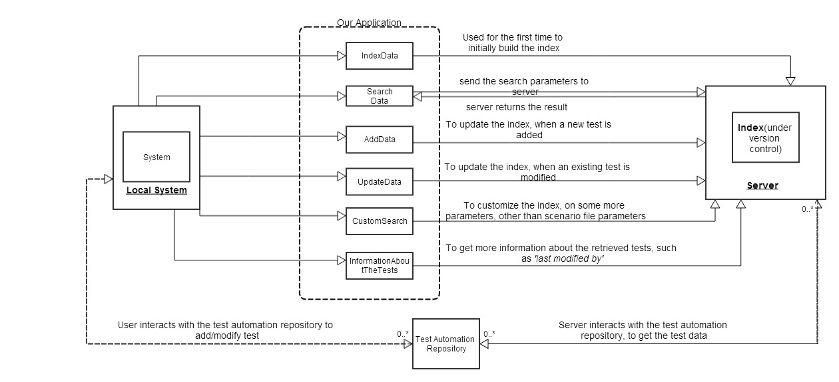
After the diagram, we have explained each function in detail.

Below are the detailed explanations and merits of all the functions:-

FUNCTIONS:

1.) IndexData (Priority : High)

Operation :

We aim to follow the approach of indexing the data first.
How do we plan to index :=>
Example: There are 35 folders in the cws repository. Each folder contains the tests for its department.

Now, we will create an index file for each folder. Each file will contain an inverted index, based on all the three columns, action_name, param and comments each.

Inverted index for a folder would be like this: action_name : list of scenario files that contain that action name
param : list of scenario files whose param is a part of this param.
Comments : list of scenario files whose comment is a part of this comment.

All these three inverted indexes will be stored in a single file for each folder and we will store the offset of each.

So, this is the approach that we will follow.

Merits:

1. We assume about the business, that the probability that the existing scenario files will be changed is very less, almost no. So, its better to read the files only once and index their data, so that we don't have to read the files again and again on each request.
2. Using the indexing approach, the user would be able to easily extend the system. If we add a new test, the system will be able to handle it.
3. The business would be more flexible, on using this approach. The user can delete any existing test, or modify it, the tool will be able to deal with it efficiently.

2.)SearchData (Priority : high)

Operation:

The user will use this method to search for the tests, required by his business.
The search method will take either a action_name, or a param, or a comment, or a combination of any two or all the three.
There is also an optional parameter for a folder path, that will narrow down the search to a folder.

If the user provides any folder path , the system will search the input parameters in the inverted index of only that folder.
If no folder path is given, it means that the user wants to search in all the folders. So, the system will search the input parameters in the inverted indexes of all the folders.

The user can also narrow down the search to multiple folders. Say, the user gives the names of 3 folders in which they want to search, so, we will search the input parameters in the indexes of only those three folders and then take the union of the results that we get from each folder.
In this way, the user can access the full power of the system, and improve his business.

The system shows the list of test files results with a view of the line that matches the search keywords along with some neighbor lines, so that the user can confirm that the files actually contain the search parameters. The system will show some N lines around the search parameter, for a file. The value of N may be 2 or 3, which will be discussed in the prototype designing.

Partial search : The user can also perform partial search on the param and comm column. This feature can prove to be very useful for the test automation team.

Merits:

1. The user won't have to go to each of the test manually. Using this method, the user can search for the test and he can get the results in very less time.
2. This method would be very convenient for the user to carry out the search operation. The user just has to give the input parameters, on which he/she wants to search.
3. The user can improve the efficiency of his business by narrowing down the search to some specific folders, instead of all the folders.

3.)AddData (Priority : high)

Operation:

The user will use this method to add new tests to his/her business.
The system is flexible enough to handle the addition of new test.

For Example,
The test automation team adds a new test in the CWS repository. In this case, the system will only run on that added test and add its inverted index.
We do not need to interfere with the existing index.

Merits:

1. Earlier, the effort of the user increased when we added new tests to the business. The user had to now spend more time searching for the tests he want.
But now, the system will automatically handle the addition of new tests, so that the time to search remains the same. This improves the efficiency of the user.
2. The search time of the user will remain same, as the system will take care of the new test and add its index.
3. User does not need not to interfere with the existing tests of the business. The user just need to tell the system what test has been added.

4.)UpdateData (Priority : high)

Operation:
The user will use this method to delete/change any existing tests from his/her business.
The system can handle the deletion/update of a test.

For example,
The test automation team deletes a test (scenario file). In this case, the tool will run again and update the index. We do not need to touch other folder’s indexes.

Merits:

1. Earlier, the effort of the user increased when we updated/deleted the existing tests to the business. The user had to remember what tests have been changed.
But now, the system will automatically handle the update of new tests, so that the time to search remains the same. This improves the efficiency of the user as well as the business.
2. The search time of the user will remain same, as the system will take care of the updated/deleted test and add its index.
3. User does not need not to interfere with the existing tests of the business. The user just need to tell the system what test has been deleted/updated.

5.) CustomSearch (Priority : medium)

Operation:

The user will use this function to extend his business.
There are many files other than the scenario files in each of the tests, that are used by the test. Right now, the user is searching only on the basis on scenario_information columns, as the parameters. But, in future, the business may want the user to search on some other parameters, apart from that in scenario_file. For example, the ITEM_MAPPING file, the DB_INFORMATION file. So, the system can be extended to search using these parameters also.

For this the system would make a index on the other parameters as well. Once the index is built the user can search tests on the basis of additional parameters in a precise and efficient way.

Merits:

- It would enable the user to exploit the flexibility of the system. The user can extend his business, using this property of the system.
- The test automation team will be able to manage the existing tests more efficiently with the help of this feature.

6.) InformationAboutTheTests (Priority : high)

Operation:
After getting the list of tests as a result, the user can also get more information about the tests:
This information can be:
- Which user made the last commit to the test. This is needed because, if the test fails, we need to know who changed it the last time.
- Which function of the product is tested through this test.

The user can also edit the test files after they have been retrieved.

Merits:
If the user has the above information, it helps to track down the exact cause of the failure of any test.

7.) DisplayContents (Priority : medium)

Operation:

After the user gets the list of results, he can choose to see full contents of the excel file. He can do so by clicking on the name of the excel file. The system will open the file on the server (may be using some java api), and display it to the user on a new page OR a separate section on the same page, in the browser.

Merits:

The user may want to see what exactly is written in a particular file. He may want to see what other tests does this file contains.

Without this function, the user has to manually open the file on his system, if he wants to see the contents and it takes time to open the file with office (maybe 3-4 secs). If we provide this function to the user to see the contents, we can use the java api for this, which will take less time.
Also, in this way, we can also cache the recent files on the server, which will improve the efficiency. For this purpose, we need this function.

8.) ExportResultsList(Priority : medium)

Operation:
The user, in some cases, may want to export the list of results or a subset of the results, that he gets from the application, to a file, may be a csv file or a simple text file.
In this case, the system provides the user with an option to select the files that he wants to export to the list, and then, with the click of a single button, the selected file names, can be exported to a file.

Merits:
The user may want to send the list of results to someone else for some purpose. For example, he may want to inform the other users about the tests, that need to be tested right now.

Without this function, the user has to manually write the names of the files in a file, which takes effort and time.
This function provides a very good interface for doing the same, which save the time of the user.

** Future Work:

1.) Currently, the system returns the list of tests or a single test, that is requested by the user and then, user runs it manually.

In future, if time permits, we can automate the system in a way such that it automatically runs the tests also, that are returned by it. In this case, the user would not have to run the tests manually.
This step can reduce the time very significantly.

We aim to start making our Interface Prototype of the system, as soon as our catalog is accepted.

Thank you
Yashasvi Girdhar
Sagar Balwani

Works Applications Co. Ltd.
COMPANY Web Service
Software Engineering Interns

